**BIOLOGY STANDARD LEVEL INTERNAL ASSESSMENT**

**THE EFFECT OF ALCOHOL ON PROTEIN DIGESTION RATE**

**Candidate Code:**

**Session:**

**RESEARCH QUESTION: HOW DO DIFFERENT CONCENTRATIONS OF ETHANOL, (0%, 5%, 10%, 15%, 20%, 25%, and 30%) AFFECT THE RATE OF PROTEIN DIGESTION MEASURE USING BIURET REAGENTS AND SPECTROPHOTOMETRY TECHNIQUE AT 37 C?**

Table of Contents

I. Background Information: 3

II. Personal Engagement 4

III. Hypothesis 4

IV. Predictions 4

V. Variables 5

VI. Methodology 5

VII. Procedure 6

VIII. Safety And Ethical Considerations 7

I. Data Collection 8

II. Data Processing 8

III. Analysis 12

I. Conclusion 12

II. Evaluation 13

III. Method and data 13

IV. Extension 15

# Background Information

Ethyl alcohol or ethanol is an organic colorless liquid that possesses profound mood irregularity and psychophysical effects. Ethanol is considered as one of the most toxic nutrients. Metabolism alterations in all tissue systems and organs are probably induced by ethanol. Its excessive consumption may lead to many abnormalities in the body. It is estimated that around 10% of adults are categorized as excessive users (Preedy et al., 1999). Unfortunately, this percentage is increasing among teenagers, adolescents, and women.

The hydrolysis of protein follows protein absorption in the bloodstream into polypeptides and amino acids (Del Rio et al., 2021). The chemical digestion of protein is the hydrolysis of proteins into more absorbable peptides and amino acids (Heda et al., al 2019). Pancreatic enzymes such as chymotrypsin and trypsin play a crucial role in the hydrolysis of protein in the small intestine.

In this study, the effect of different concentrations of ethanol on the enzymatic activity of trypsin is investigated. Various proteolytic enzymes attach to a nonpolar side chain of its substrate (tang, 1965). Enzymatic activity can be inhibited by various factors such as extreme temperatures, pH extremes, denaturation, and competitive inhibition. Alcohols undergo competitive inhibition may be a result of competition of the substrate with alcohols for the enzyme's binding site. Alcohols may compete to bind at the Trypsin active site. The in vitro studies of enzyme activity encompass detections like calorimetry, chromatography, mass spectroscopy, and spectrophotometry.

# Personal Engagement

Once there was a debate between my uncle who is an alcohol addict and my mom that excessive drinking with grilled meat cannot destroy his health. These never-ending arguments gave me the idea to research this topic extensively. This study may also help in the future to spread awareness regarding the adverse effects of excessive alcohol consumption. Ethanol-induced gastric ulcer mainly occurs due to smoking, alcohol consumption, and physiological stress. (Rahman et al.,2020).

# Hypothesis

**Null hypothesis (H0):** Alcohol's presencein the digestion process does not inhibit the enzymatic activity of trypsin.

**Alternative Hypothesis (H1):** the presence of alcohol in the digestion process will interfere with the efficiency of protein digestion by inhibiting the enzymatic activity of trypsin.

# Predictions

It is predicted that as the concentration of alcohol increases i.e., 0%, 5%, 10%, 15%, 20%, 25%, and 30% the rate of protein digestion will decrease.

# Variables

**Independent:** ethanol with varying concentrations of 5%, 10%, 15%, 20%, 25%, and 30%).

**Dependent:** rate of protein digestion.

**Control:** the factors in any experiment that must be kept constant to guarantee that any alterations in an experiment must be the result of independent variables are termed as constant variables or controlled variables**.** Beaker with no or 0% alcohol is the prime controlled variables.

**Table 1**

*Control variables*

|  |  |  |
| --- | --- | --- |
| **Control Variable:** | **Method of control:** | **Why it is controlled:** |
| Temperature | Temperature can be maintained through an incubator and water bath. | The activity of an enzyme and the protein structure is sensitive to temperature, and it can lead to unreliable results. |
| Protein concentration | Use the analytical balance and stock solution to measure the constant amount of protein substrate. | Variable amount of protein concentration can infer the accurate digestion rate. |
| Ethanol source | Guarantee the uniformity by using ethanol from the constant source. | Impurities in ethanol source may give unexpected results on the protein digestion rate*.* |
| Calibration of spectrophotometer | Standardize the spectrophotometer before conducting each set of readings. | The spectrophotometer may give systematic errors that disturb the reliability of experiment. |
| Path length of cuvette | The cuvettes of fixed path length must be chosen to guarantee uniformity through each measurement. | Consistency is attained by selecting cuvettes with fixed path length. |

# Methodology

Materials:

Table 2

*Materials Used in Detail*

|  |  |  |  |
| --- | --- | --- | --- |
| Material: | Amount: | Uncertainty: | Use: |
| Albumin egg white powder samples | 1% solution  3.5g |  | To determine the rate of albumin digestion. |
| Ethanol | 5%, 10%, 15%, 20%, 25%, and 30%. |  | To determine the effect of ethanol on pepsin and trypsin activity. |
| Deionized water | 1 | N/A | To make the dilutions of ethanol. |
|  |  |  |  |
| Enzyme (Trypsin) | 3 % solution  10.5g | N/A | To prepare digestion solutions. |
| Glassware (beakers, flasks, pipettes) | variable | ±0.05 cm³ | To make different solution concentrations. |
| Hot water bath | 1 | N/A | To make a water bath at 37°C |
| Spectrophotometer | 1 | N/A | To measure the absorbance. |
| Biuret reagent (NaOH and CuSO4) | a few drops per trial  2% CuSO4  10% NaOH | N/A | To measure the protein concentrations. |
| Stopwatch or timer | 1 | N/A | To measure the time. |
| Analytical balance | 1 | N/A | To weigh the quantities. |
| Thermometer | 1 | N/A | To measure the temperature. |

# Procedure

1. Prepare your albumin egg white powder solutions (1%). Weigh out 3.5 grams of the powder using the analytical balance and add 350ml of water.
2. Prepare your digestion solutions by adding the trypsin to deionized water. Make a 3% solution of trypsin. Weigh out 10.5 grams of the powder using the analytical balance and add 350ml of water.
3. Prepare ethanol solutions of different concentrations by diluting ethanol with deionized water. For the specified concentrations (0%, 5%, 10%, 15%, 20%, 25%, and 30%), add each solution to the corresponding beakers containing the albumin egg white powder and enzyme solution.
4. Combine the albumin solutions with the ethanol solutions.
5. Set the spectrophotometer to 570nm and calibrate it with a blank cuvette.
6. Take samples from the beakers and add biuret reagents and measure the initial absorbance.
7. Add the trypsin solutions to the beakers.
8. Place the beakers in a water bath at body temperature (37°C).
9. Leave the samples to digest for 10 minutes. Note the time of initiation of the digestion process.
10. After the digestion process, add the Biuret reagents to the solutions.
11. Measure the Final absorbance values of the solutions.
12. Record the results and repeat for 4 more trials.

# Safety And Ethical Considerations

* Guarantee the discarding and appropriate handling of hazardous chemicals like ethanol
* Safety lab protocol for using and handling spectrophotometers should be followed.
* Ethical considerations and standards should be kept in mind while analyzing and reporting the data.

## Data Collection

Record the absorbance values from the spectrophotometer for each sample after 10 minutes, which correlates to the protein concentration. The greater the absorbance values, the less protein remaining, the more complete the digestion process. Plot these values against time to get a digestion curve for each alcohol concentration.

Table 3

*Absorbance values for different alcohol concentrations at the beginning and end*

|  |  |  |  |
| --- | --- | --- | --- |
| % ethanol concentration | Trial | Initial (nm) | Final (nm) |
| 0% | 1 | 0.829 | 0.345 |
|  | 2 | 0.848 | 0.322 |
|  | 3 | 0.856 | 0.354 |
|  | 4 | 0.850 | 0.372 |
|  | 5 | 0.848 | 0.367 |
| 5% | 1 | 0.842 | 0.437 |
|  | 2 | 0.842 | 0.470 |
|  | 3 | 0.852 | 0.422 |
|  | 4 | 0.843 | 0.453 |
|  | 5 | 0.864 | 0.448 |
| 10% | 1 | 0.869 | 0.504 |
|  | 2 | 0.867 | 0.528 |
|  | 3 | 0.840 | 0.515 |
|  | 4 | 0.859 | 0.571 |
|  | 5 | 0.847 | 0.499 |
| 15% | 1 | 0.848 | 0.555 |
|  | 2 | 0.849 | 0.585 |
|  | 3 | 0.866 | 0.592 |
|  | 4 | 0.825 | 0.543 |
|  | 5 | 0.826 | 0.578 |
| 20% | 1 | 0.822 | 0.620 |
|  | 2 | 0.823 | 0.630 |
|  | 3 | 0.861 | 0.617 |
|  | 4 | 0.859 | 0.648 |
|  | 5 | 0.863 | 0.643 |
| 25% | 1 | 0.835 | 0.703 |
|  | 2 | 0.868 | 0.679 |
|  | 3 | 0.860 | 0.688 |
|  | 4 | 0.844 | 0.672 |
|  | 5 | 0.859 | 0.660 |
| 30% | 1 | 0.832 | 0.711 |
|  | 2 | 0.828 | 0.723 |
|  | 3 | 0.852 | 0.705 |
|  | 4 | 0.829 | 0.699 |
|  | 5 | 0.866 | 0.725 |

## 

## Sample calculation:

## Average absorbance: Trial 1+ Trial 2+ Trial 3+ Trial 4+ Trial 5 / 5 =

## 0.829+0.848+0.856+0.850+0.848 = 0.8462

## Percent change = average initial - average final / average initial x100% =

0.8462-0.352 / 0.8462 x100% = 58.40%

Table 4: average values and percent change

|  |  |  |  |
| --- | --- | --- | --- |
| % ethanol concentration | Initial avg (nm) | Final avg (nm) | Percent change (%) |
| 0% | 0.8462 | 0.352 | 58.40 |
| 5% | 0.8486 | 0.446 | 47.44 |
| 10% | 0.8564 | 0.5234 | 38.88 |
| 15% | 0.8428 | 0.5706 | 32.30 |
| 20% | 0.8456 | 0.6316 | 25.31 |
| 25% | 0.8532 | 0.6804 | 20.25 |
| 30% | 0.8414 | 0.7126 | 15.31 |

## Data Processing

In medical studies, Analysis of variance (ANOVA) is among the most readily exercised methods (Kim, 2017). ANOVA supposes that the population or numbers have identical variances. F statistic used by ANOVA is the quotient of variances within and between the sets. F statistic can be calculated by using the formula:

*F*=*MSW/MSB*​

where MSB is the average square between sets and MSW is the average square within sets.

We reject the null hypothesis if the selected significant value (usually 0.05), is less than the p-value.

H0: µ1 = µ2 = µ3

H1: µ1 ≠ µ2*or* µ1 ≠ µ3*or* µ2 ≠ µ3

* **Statistic (F-value): 2.4909**
* **P-value: 0.0375**

**Interpretation**

* **F-value:** the measure of the quotient of the variance between the sets to the variance within the sets. An elevated value indicates a substantial difference between the groups.
* **P-value:** the importance of the results obtained is determined by this value**.** A p-value less than 0.05 implies that the variations in average absorbance between the distinct alcohol concentrations are statistically large.
* As the p-value is less than 0.05, the variance in the absorbance values for various alcohol concentrations is statistically large. Thus, this strongly strengthens the hypothesis that with the variation in alcohol concentrations, the protein digestion rate also varies.
* ANOVA analysis plays a crucial role in the data presentation and processing, giving statistical support for the backup of lab observations.

Graph 1

Relative Digestion Levels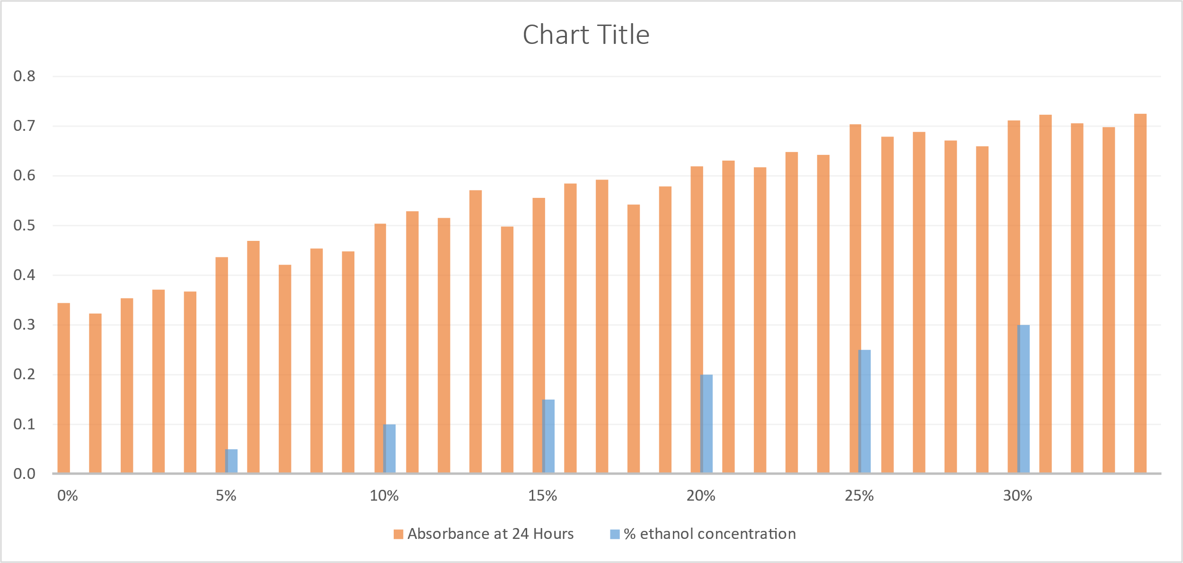

**Graph Interpretation**

* The bar graph given here shows the digestion levels at different concentrations of alcohol after 24 hours.
* It assesses the absorbance levels which represent the effectiveness of protein digestion at different alcohol concentrations.
* Lesser absorbance values denote more effective protein digestion, whereas greater absorbance values denote inhibition of the proteolytic activity of pepsin and trypsin due to the presence of alcohol.

Graph 2:

The efficiency of protein digestion rate under different alcohol concentrations.

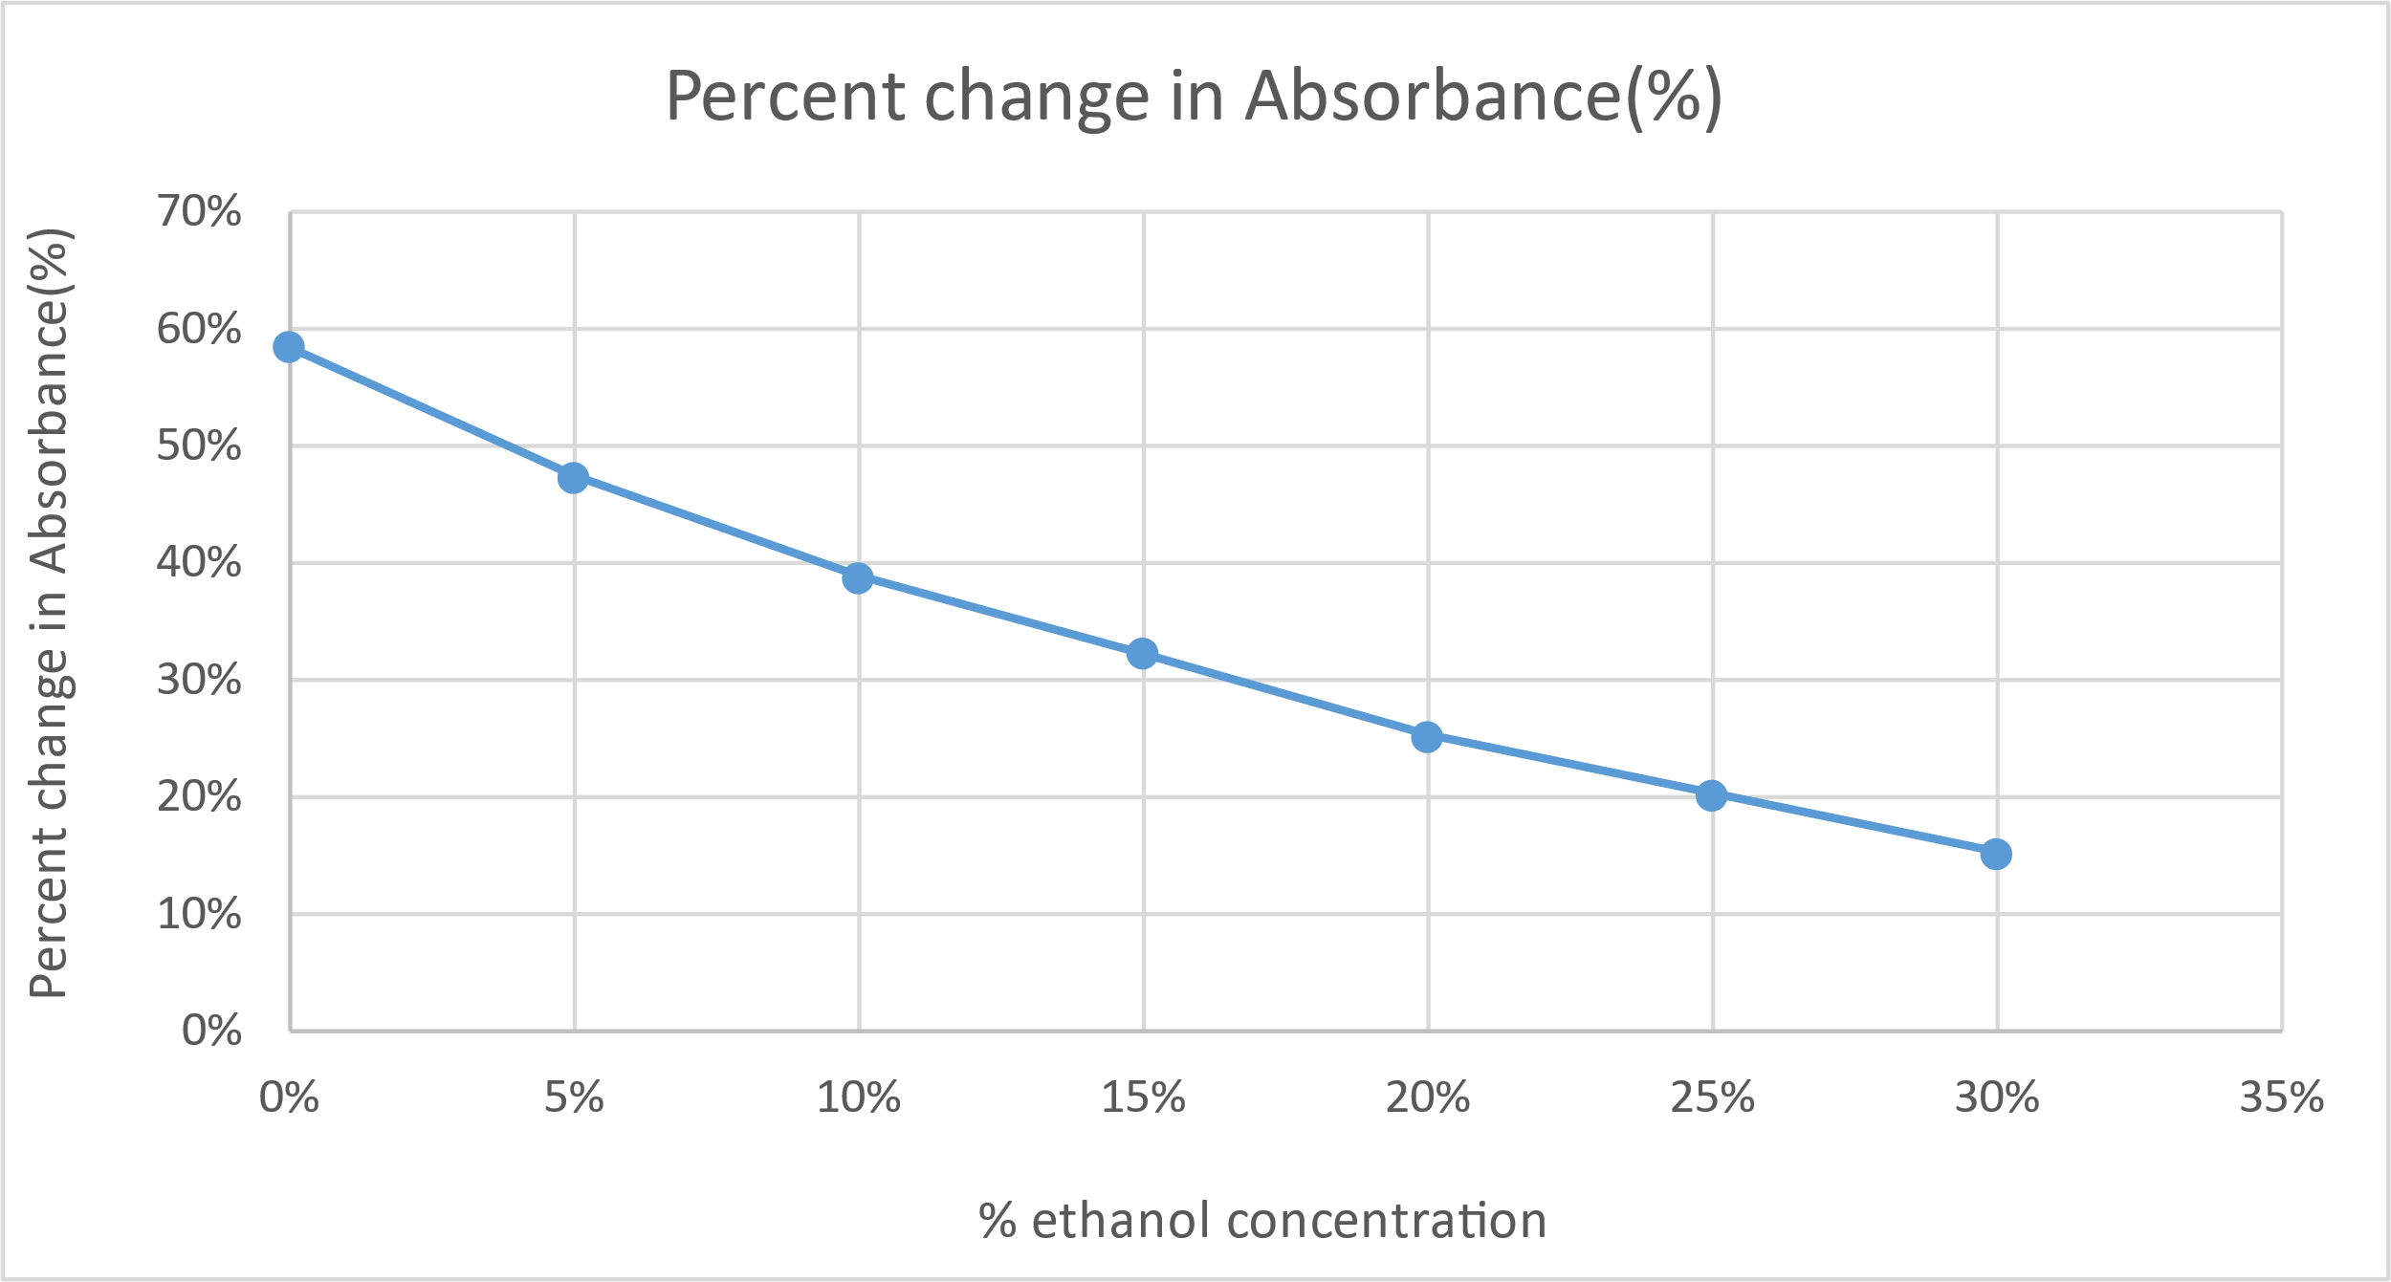

**Graph Interpretation**

* The line graph displays the rate of protein digestion under various alcohol concentrations.
* Higher absorbance values, i.e., slower digestion with increasing alcohol concentration is observed.
* The decrease in absorbance reduces with the increase in alcohol concentration implying the inhibition of enzymatic activity.

## Analysis

The observations, data processing, and graphs from the performed experimentation show some strong key findings regarding the effect of alcohol on protein concentrations. The highest protein digestion rate was observed in the control (0% alcohol), denoted by the steepest decrease in absorbance. Thus, the enzymatic activity of pepsin and trypsin is efficient in the alcohol absence. There was a significant decline in protein digestion as the increase in alcohol concentration. A less steep decrease in the absorbance values with higher concentrations of alcohol supports this evidence. For example, the set with an alcohol concentration of 30% indicates the slowest digestion rate. The enzymatic activity of digestive enzymes like pepsin and trypsin is strongly inhibited in the increasing concentration of alcohol. The higher the alcohol concentration the stronger will be the inhibition in enzymatic activity. Constant patterns were observed in all the observations implying the trend of increasing alcohol concentration with the decrease in digestion rate was consistent. No considerable anomalies across the data were observed therefore improving the result's reliability. The results obtained strongly support the hypothesis that the increasing concentrations of alcohol inhibit the enzymatic activity of pepsin and trypsin. Pepsin and trypsin are important digestive enzymes and thus alter the digestion of protein.

**Biology Higher Level Internal Assessment- Evaluation**

### Conclusion

The performed experiment strongly supports an alcohol concentration-dependent inhibitory influence on the enzymatic activity of pepsin and trypsin. The effect of alcohol on trypsin activity has previously been researched (Edie,1919). The data collected were sufficient to prove that alcohol has a remarkable inhibitory effect of trypsin in the digestion of fibrin when present in percentages of 3 to 7. The digestion of protein fibrin was entirely inhibited in the higher alcohol concentrations, but it fairly digests protein caseinogen. The digestion of fibrin was entirely inhibited in the presence of a 25% concentration of alcohol. The digestion of fibrin is 10-20 % control with no ethanol in the presence of a 12% concentration of alcohol. The zymoid modification of enzyme suggests that different side chains of enzyme molecules are responsible for the digestion of different protein molecules. The reliability of the performed hypothesis is ensured by the incorporation of various replicates for different concentrations of alcohol. The reproducibility of the obtained results is achieved by the constant trends over different concentrations of alcohol. Although the experiment conducted contains some limitations and constraints that must be dealt with. The controlled variables like standardized preparation of solutions and constant temperature contribute to the validity of the performed experiment. The research laboratory may not fulfill the vast complexities of the actual digestive system of humans. The albumen egg white powder may not be a potential alternative to whole dietary proteins consumed by humans and other organisms.

### Evaluation

This investigation can answer many queries and research regarding the adverse health effects of chronic consumption of alcohol. Ethanol affects all tissues of mammals, including the Musculoskeletal system, hepato-intestinal, and cardiovascular systems. (Preedy et al., 1999). The collagen accumulation in the liver is characterized by Cirrhosis, developed because of chronic misuse of alcohol. However, certain limitations that researchers may encounter can profoundly impact the execution, interpretation, and design of the experiments.

### Method and data

The methodology used was beneficial in ensuring valid and reliable results. future research implicating a broad range of protein substrates can enhance the generalizability of the research.

Some of the constraints occurred in the experiments that must be addressed. Some of the errors that have a significant impact on the validity of the experiment is mentioned below:

Table 5:

*Different types of errors*

|  |  |  |  |
| --- | --- | --- | --- |
| **Problem** | **Explanation of problem** | **Improvement** | **Explanation of improvement** |
| pH alterations. | Proteins and enzymes function at the optimum pH range alterations in pH can affect their activity. | pH meter and different sorts of buffer. | Solutions should be buffered to maintain pH. meter should also be used for calibrations. |
| Inaccuracy in pipetting. | The precision of results is greatly affected by pipetting inaccuracy. (biuret) | Use well-maintained and calibrated pipettes. | Pipetting using automated systems and rechecking measurements can greatly reduce inaccuracy. |

### Extension

This investigation can be expanded by selecting a broad range of protein substrates constituting an organism's distinctive diet. This advancement would surely enhance the generalizability of the research experiment. The adverse health effects of alcohol can also be investigated which would provide researchers with new insights and understanding. The enzymatic activities of various enzymes can also be investigated by implicating more accurate analytical methods.

**References**

Del Rio, A. R., Keppler, J. K., Boom, R. M., & Janssen, A. E. (2021). Protein acidification and hydrolysis by pepsin ensure efficient trypsin-catalyzed hydrolysis. *Food & Function*, *12*(10), 4570-4581.

Edie, E. S. (1919). The Effect of Alcohol on the Digestion of Fibrin and Caseinogen by Trypsin. *Biochemical Journal*, *13*(2), 219.

Heda, R., Toro, F., & Tombazzi, C. R. (2019). Physiology, pepsin.

Kim, T. K. (2017). Understanding one-way ANOVA using conceptual figures. *Korean journal of anesthesiology*, *70*(1), 22-26.

Preedy, V. R., Reilly, M. E., Patel, V. B., Richardson, P. J., & Peters, T. J. (1999). Protein metabolism in alcoholism: effects on specific tissues and the whole body. *Nutrition*, *15*(7-8), 604-608.

Preedy, V. R., Reilly, M. E., Patel, V. B., Richardson, P. J., & Peters, T. J. (1999). Protein metabolism in alcoholism: effects on specific tissues and the whole body. *Nutrition*, *15*(7-8), 604-608.

Rahman, Z., Dwivedi, D. K., & Jena, G. B. (2020). Ethanol-induced gastric ulcer in rats and intervention of tert-butylhydroquinone: Involvement of Nrf2/HO-1 signalling pathway. *Human & Experimental Toxicology*, *39*(4), 547-562.

Tang, J. (1965). Competitive inhibition of pepsin by aliphatic alcohols. *Journal of Biological Chemistry*, *240*(10), 3810-3815.